System Requirements Specification Index

For

Snowflake ETL Query surge testing use case

Version 1.0

IIHT Pvt. Ltd.

[fullstack@iiht.com](mailto:fullstack@iiht.com)

Problem Statement : Snowflake ETL Testing use case

Description : Use relevant methods operations toperform specified activities which are given in the instructions.

A school district wants to centralize student information from multiple schools for reporting and analysis purposes. Each school provides daily updates in flat files (CSV format) containing student information such as attendance, grades, and personal details. The goal is to load this data into Snowflake for easy access and reporting.

# Objectives

1. **Extract** student information data from flat files.
2. **Transform** the data to ensure it is clean, standardized, and enriched.
3. **Load** the transformed data into Snowflake for further analysis and reporting.

# . Extract Data from Flat Files

* **Source**: Daily CSV files from multiple schools.

# Fields:

* StudentID (NUMBER)
* Age (NUMBER)
* GenderEthnicity (NUMBER)
* ParentalEducation( VARCHAR)
* StudyTimeWeekly ( VARCHAR)
* Absences( VARCHAR)
* Tutoring( VARCHAR)
* ParentalSupport( VARCHAR)
* Extracurricular( VARCHAR)
* Sports( VARCHAR)
* Music( VARCHAR)
* Volunteering( VARCHAR)
* GPA(NUMBER)
* Steps to login in the snowflake account
* Use the credential given to you though your host

Note :

PLEASE CREATE THE DATATYPES ACCORDING TO THE SPECIFICATIONS

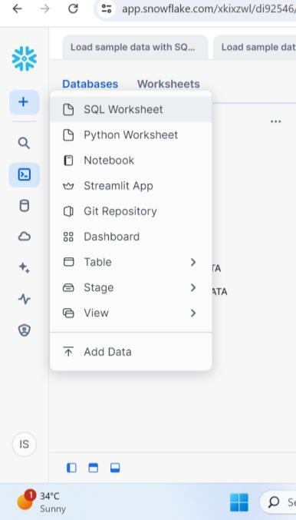

* Click on the sql worksheet to open the query editor

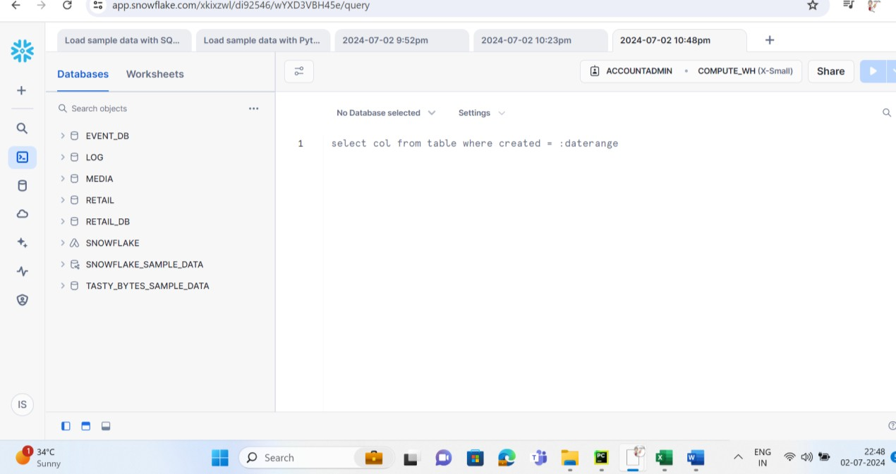

You will need to create the database and move inside the database

Once you have imported the table check for respective rows and columns are imported correctly.

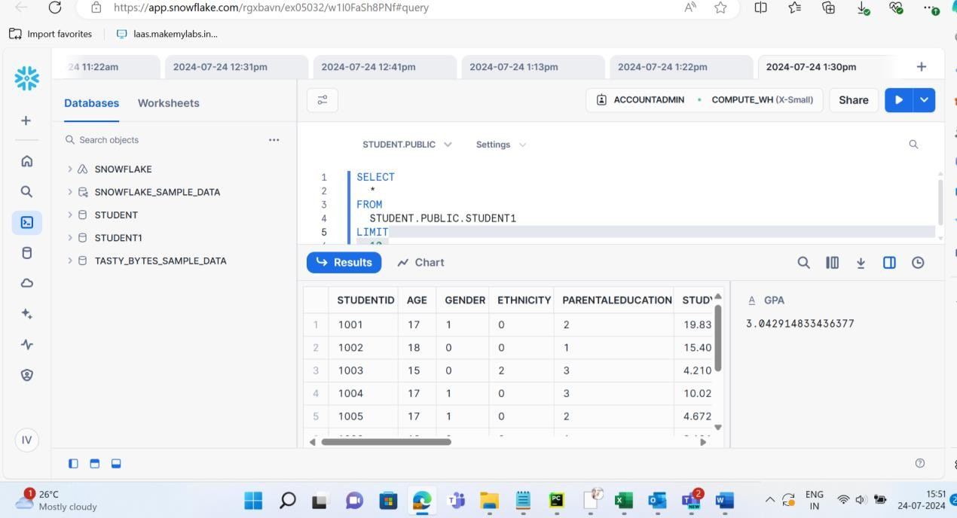

In query surge we need to import flat file

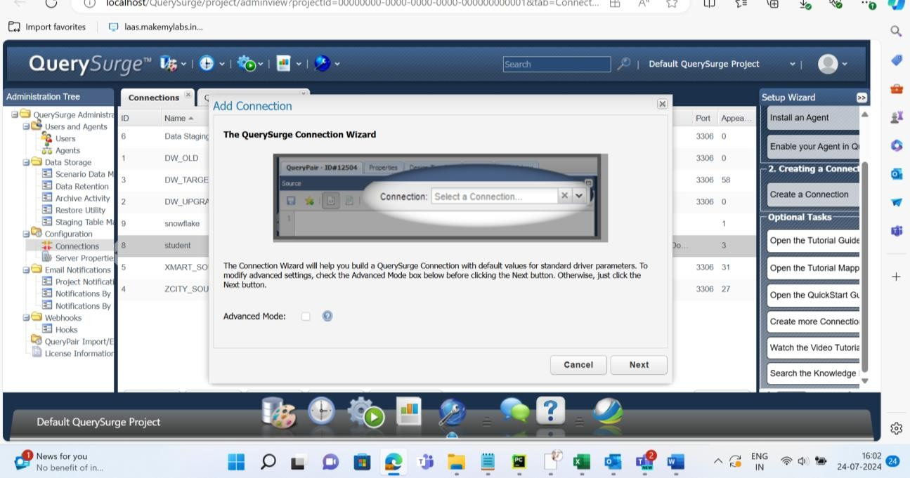

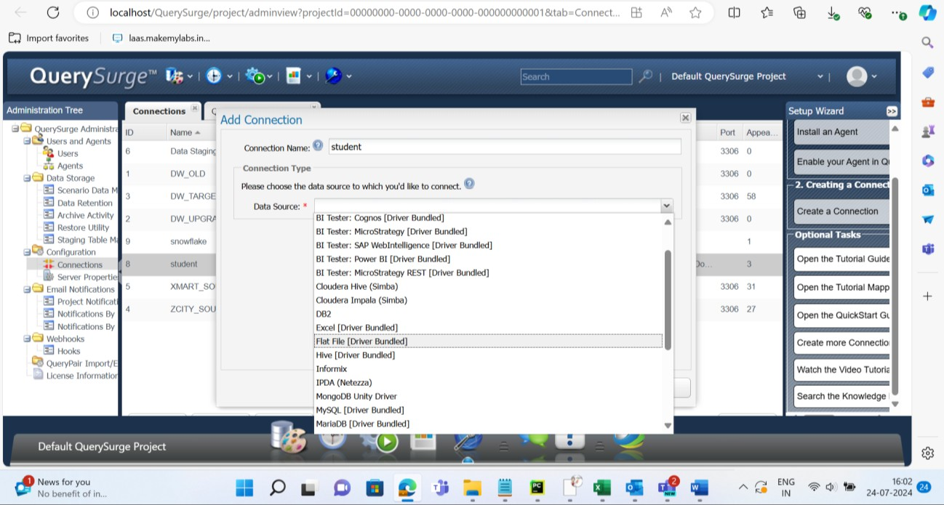

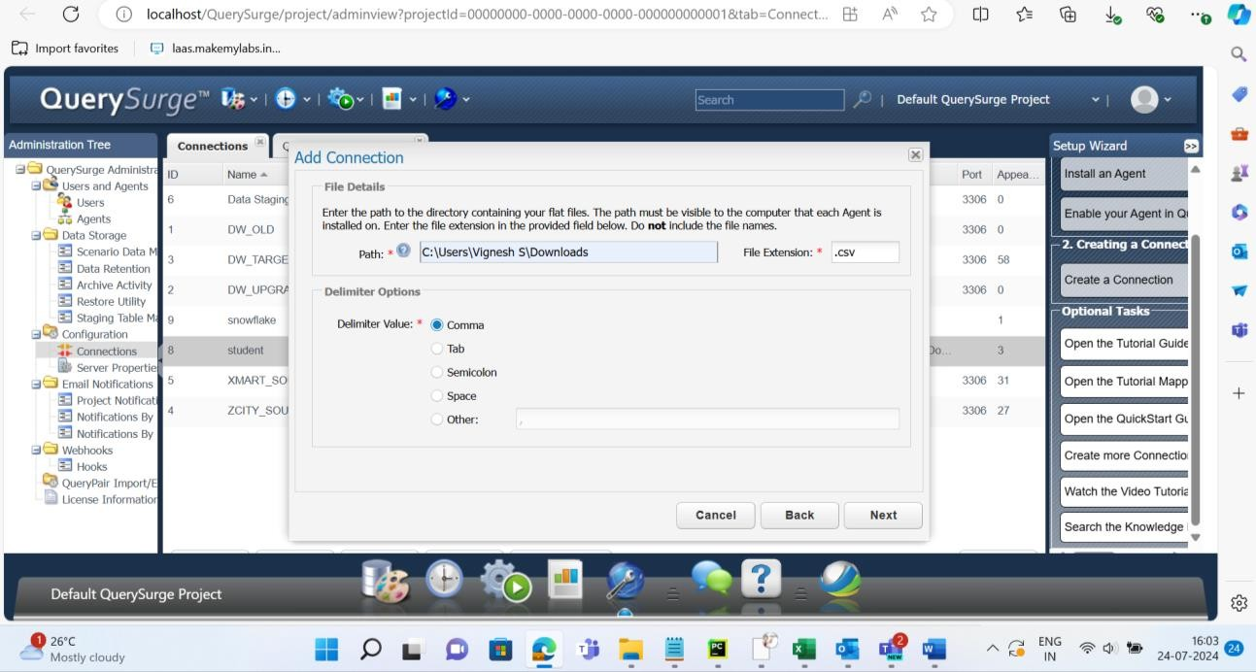

Give the path for the csv file

Provide the input columns in the corresponding input

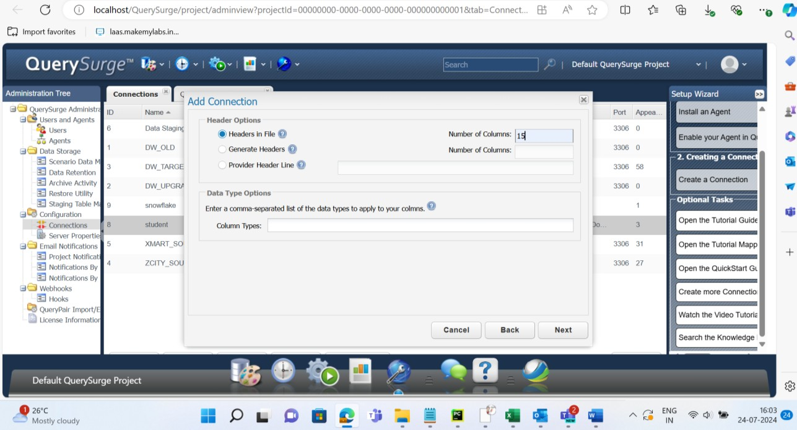

Snowflake connection

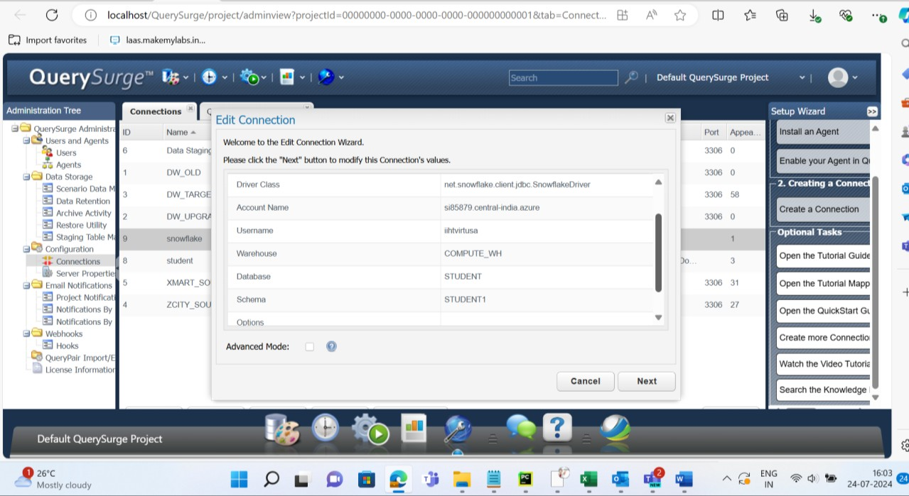

Perform two queries in source and target and run the query to validate the values in the tables

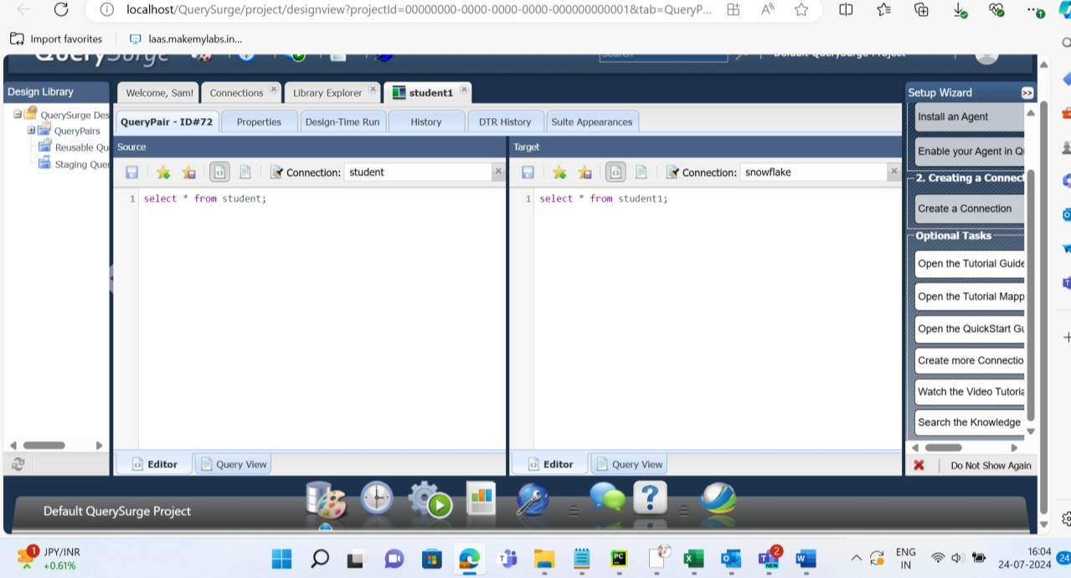

Example of failed data comparison

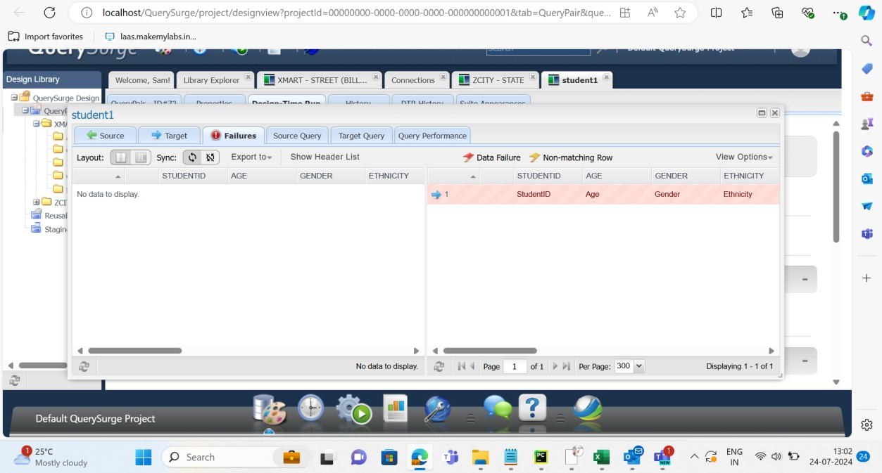

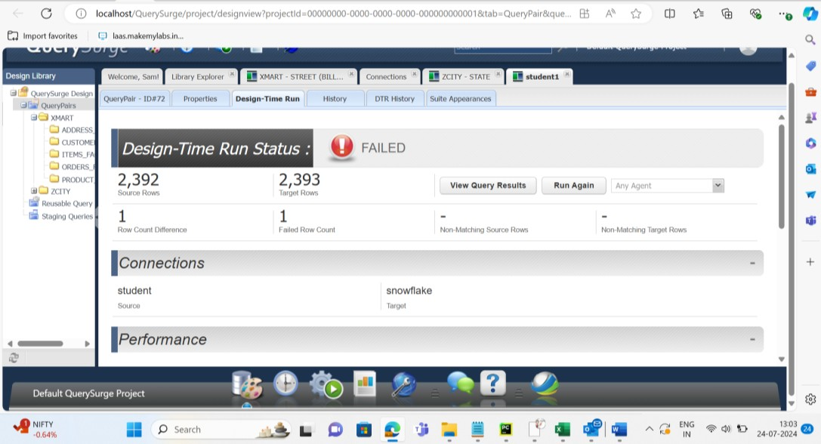

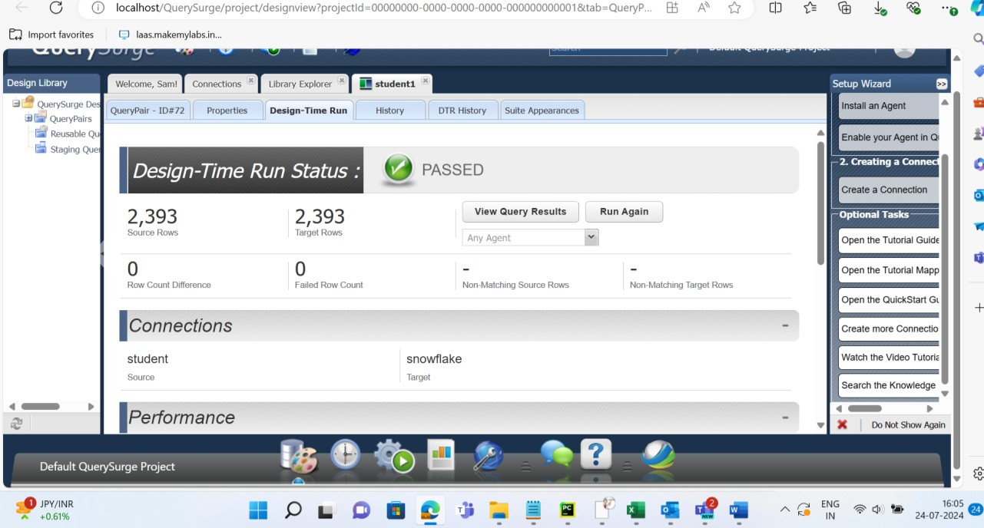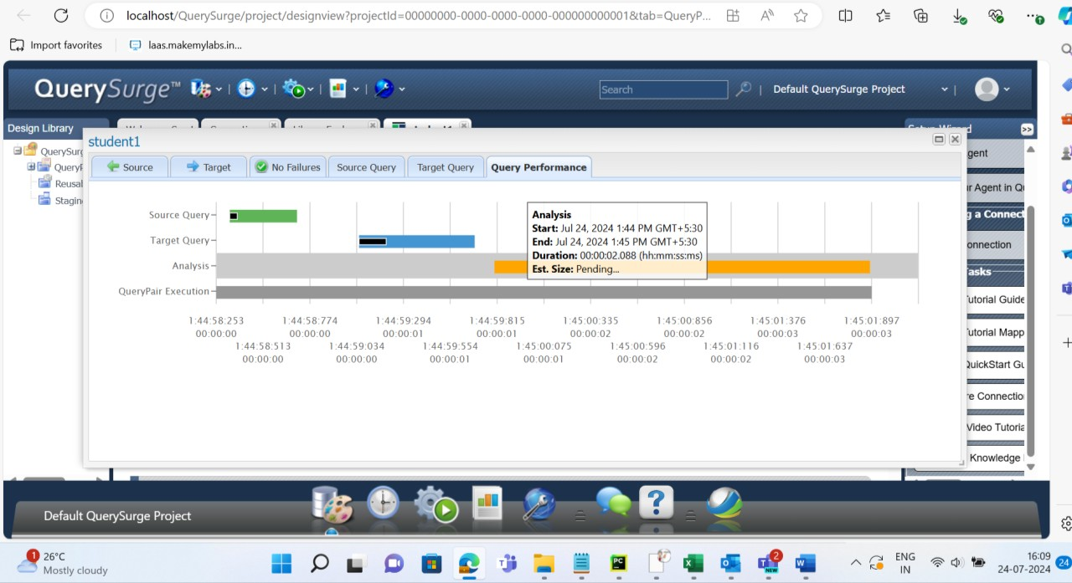

**Task A to be performed**

1 Upload the data to query surge 2 Upload the data to snowflake

3 Configure query surge for snowflake and flatfile connection 4 Creating query to load the data from source to target

5 Compare two tables with source table and target table for changes 6 Check and modify using queries for query testing

# Execution Steps to Follow:

* 1. Open the snowflake console
  2. Import the dataset from the document
  3. Perform all the query respective to the question provided
  4. Take screenshots of the query execution
  5. Upload the code to the Github
  6. Download the report from query surge

# -----x-----